Project Title:
UART SERIAL COMMUNICATION

19ECE383 VLSI Design Lab
B. Tech. ECE
Batch: C1

2023-2024 Even Semester

CB.EN.U4ECE21243 | PUJIITA SRIEYA BOLISETTY
CB.EN.U4ECE21244 | PUPPALA SRAVAN
CB.EN.U4ECE21256 | SIVARAJU VENKATA SAI KARTHIK

Faculty Incharges: Dr. Navya Mohan, Dr. Anita J.P

Signature of the Faculty:

Department of Electronics and Communication Engineering
Amrita School of Engineering
Amrita Vishwa Vidyapeetham
Amritanagar, Coimbatore – 641112

- Objective: The objective of this project report is to design and implement a UART (Universal Asynchronous Receiver/Transmitter) interface using VHDL,Vivado,Basys-3 Board where the input is given in the basys-3 board in the ascii format and the character is visualized in the computer in the tera term terminal, and the received character’s ascii code is visualized with the help of led’s on board.

- Software hardware used:

Software apps:- Vivado,Tera Term,ModelSim
Hardware components:- Digilent Basys 3

- Overview of the system:
This system implements a UART (Universal Asynchronous Receiver Transmitter) controller along with supporting modules such as UART transmitter and receiver, UART button debounce, and clock generators.

1. UART Controller (UART_controller):
- Acts as the central component integrating the UART transmitter and receiver.
- Interfaces with external entities like the clock (`clk`), reset (`reset`), transmission enable (`tx_enable`), data input (`data_in`), data output (`data_out`), receive (`rx`), and transmit (`tx`) signals.

2. UART Transmitter (UART_tx):
- Generates serial data for transmission based on parallel input data (`tx_data_in`) and a start signal (`tx_start`).
- Implements a finite state machine (`UART_tx_FSM`) to handle the transmission process, including start bit, data bits, and stop bit generation.

3. UART Receiver (`UART_rx`):
- Receives serial data and converts it into parallel data (`rx_data_out`).
- Also utilizes a finite state machine (`UART_rx_FSM`) to synchronize with the incoming serial data stream.

4. UART Button Debounce (`button_debounce):
- Debounces a button input (`button_in`) to prevent multiple signals due to mechanical noise or bouncing.
- Generates a clean output signal (`button_out`) indicating a stable button press.

5. Clock Generation:
- Generates clocks (`clk`) for system synchronization and baud rate timing.
- Implements clock dividers to derive baud rate clocks for UART transmitter and receiver.

6. Testbench (`UART_controller_tb):
- Provides a simulation environment to test the functionality of the UART controller and its associated modules.
- Simulates clock generation, button presses, and data transmission/reception to verify the system's behavior.

Overall, the system enables communication between devices using UART protocol, ensuring reliable transmission and reception of data while handling debouncing for user input.

- Block diagram:
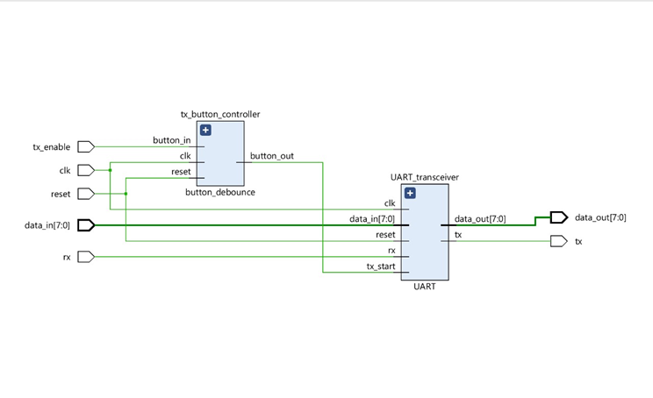
- Introduction: UART is a critical protocol for serial communication, widely used in embedded systems for data exchange between devices such as microcontrollers, computers, and peripheral devices. This design allows transmitting bits from the board to the computer terminal, and receiving bits from the terminal to the board. You can transmit data from the board to the terminal by pressing the push button on the board. Transmitting bits can be set by using the user switches, and receiving bits can be checked on the user LEDs.

- Complete Code with comments:

--Transmitter Module
library ieee;
use ieee.std_logic_1164.all;
use ieee.numeric_std.all;

entity UART_tx is

generic(
BAUD_CLK_TICKS: integer := 868); -- clk/baud_rate (100 000 000 / 115 200 = 868.0555)
port(
clk : in std_logic;
reset : in std_logic;
tx_start : in std_logic;
tx_data_in : in std_logic_vector (7 downto 0);
tx_data_out : out std_logic
);
end UART_tx;

architecture Behavioral of UART_tx is

type tx_states_t is (IDLE, START, DATA, STOP);
signal tx_state : tx_states_t := IDLE;
signal baud_rate_clk : std_logic:= '0';
signal data_index : integer range 0 to 7 := 0;
signal data_index_reset : std_logic := '1';
signal stored_data : std_logic_vector(7 downto 0) := (others=>'0');
signal start_detected : std_logic := '0';
signal start_reset : std_logic := '0';
begin
-- The baud_rate_clk_generator process generates the UART baud rate clock by
-- setting the baud_rate_clk signal when the counter counts BAUD_CLK_TICKS
-- ticks of the master clk. The BAUD_CLK_TICKS constant is specified in
-- the package and reflects the ratio between the master clk and the baud rate.

baud_rate_clk_generator: process(clk)
variable baud_count: integer range 0 to (BAUD_CLK_TICKS - 1) := (BAUD_CLK_TICKS - 1);
begin
if rising_edge(clk) then
if (reset = '1') then
baud_rate_clk <= '0';
baud_count := (BAUD_CLK_TICKS - 1);
else
if (baud_count = 0) then
baud_rate_clk <= '1';
baud_count := (BAUD_CLK_TICKS - 1);
else
baud_rate_clk <= '0';
baud_count := baud_count - 1;
end if;
end if;
end if;
end process baud_rate_clk_generator;

-- The tx_start_detector process works on the master clk frequency and catches
-- short (one clk cycle long) impulses in the tx_start signal and keeps it for
-- the UART_tx_FSM. tx_start_detector is needed because the UART_tx_FSM works on
-- the baud rate frequency, but the button_debounce module generates one master clk
-- cycle long impulse per one button push. start_detected keeps the information that
-- such event has occurred.
-- The second purpose of tx_start_detector is to secure the transmitting data.
-- stored_data keeps the transmitting data saved during the transmission.

tx_start_detector: process(clk)
begin
if rising_edge(clk) then
if (reset ='1') or (start_reset = '1') then
start_detected <= '0';
else
if (tx_start = '1') and (start_detected = '0') then
start_detected <= '1';
stored_data <= tx_data_in;
end if;
end if;
end if;
end process tx_start_detector;

-- The data_index_counter process is a simple counter from 0 to 7 working on the baud
-- rate frequency. It is used to perform transformation between the parallel
-- data (stored_data) and the serial output (tx_data_out).
-- The data_index signal is used in UART_tx_FSM to go over the stored_data vector
-- and send the bits one by one.

data_index_counter: process(clk)
begin
if rising_edge(clk) then
if (reset = '1') or (data_index_reset = '1') then
data_index <= 0;
elsif (baud_rate_clk = '1') then
data_index <= data_index + 1;
end if;
end if;
end process data_index_counter;
-- The UART_FSM_tx process represents a Finite State Machine which has
-- four states (IDLE, START, DATA, STOP). See inline comments for more details.

UART_tx_FSM: process(clk)
begin
if rising_edge(clk) then
if (reset = '1') then
tx_state <= IDLE;
data_index_reset <= '1'; -- keep data_index_counter on hold
start_reset <= '1'; -- keep tx_start_detector on hold
tx_data_out <= '1'; -- keep tx line set along the standard
else
if (baud_rate_clk = '1') then -- the FSM works on the baud rate frequency
case tx_state is

when IDLE =>
data_index_reset <= '1'; -- keep data_index_counter on hold
start_reset <= '0'; -- enable tx_start_detector to wait for starting impulses
tx_data_out <= '1'; -- keep tx line set along the standard

if (start_detected = '1') then
tx_state <= START;
end if;

when START =>
data_index_reset <= '0'; -- enable data_index_counter for DATA state
tx_data_out <= '0'; -- send '0' as a start bit

tx_state <= DATA;

when DATA =>
tx_data_out <= stored_data(data_index); -- send one bit per one baud clock cycle 8 times

if (data_index = 7) then
data_index_reset <= '1'; -- disable data_index_counter when it has reached 8
tx_state <= STOP;
end if;

when STOP =>
tx_data_out <= '1'; -- send '1' as a stop bit
start_reset <= '1'; -- prepare tx_start_detector to be ready detecting the next impuls in IDLE

tx_state <= IDLE;

when others =>
tx_state <= IDLE;
end case;
end if;
end if;
end if;
end process UART_tx_FSM;
end Behavioral;

--Receiver Module
library ieee;
use ieee.std_logic_1164.all;
use ieee.numeric_std.all;
entity UART_rx is

generic(
BAUD_X16_CLK_TICKS: integer := 54); -- (clk / baud_rate) / 16 => (100 000 000 / 115 200) / 16 = 54.25
port(
clk : in std_logic;
reset : in std_logic;
rx_data_in : in std_logic;
rx_data_out : out std_logic_vector (7 downto 0)
);
end UART_rx;

architecture Behavioral of UART_rx is

type rx_states_t is (IDLE, START, DATA, STOP);
signal rx_state: rx_states_t := IDLE;
signal baud_rate_x16_clk : std_logic := '0';
signal rx_stored_data : std_logic_vector(7 downto 0) := (others => '0');
begin
-- The baud_rate_x16_clk_generator process generates an oversampled clock.
-- The baud_rate_x16_clk signal is 16 times faster than the baud rate clock.
-- Oversampling is needed to put the capture point at the middle of duration of
-- the receiving bit.
-- The BAUD_X16_CLK_TICKS constant reflects the ratio between the master clk
-- and the x16 baud rate.
baud_rate_x16_clk_generator: process(clk)
variable baud_x16_count: integer range 0 to (BAUD_X16_CLK_TICKS - 1) := (BAUD_X16_CLK_TICKS - 1);
begin
if rising_edge(clk) then
if (reset = '1') then
baud_rate_x16_clk <= '0';
baud_x16_count := (BAUD_X16_CLK_TICKS - 1);
else
if (baud_x16_count = 0) then
baud_rate_x16_clk <= '1';
baud_x16_count := (BAUD_X16_CLK_TICKS - 1);
else
baud_rate_x16_clk <= '0';
baud_x16_count := baud_x16_count - 1;
end if;
end if;
end if;
end process baud_rate_x16_clk_generator;

-- The UART_rx_FSM process represents a Finite State Machine which has
-- four states (IDLE, START, DATA, STOP). See inline comments for more details.

UART_rx_FSM: process(clk)
variable bit_duration_count : integer range 0 to 15 := 0;
variable bit_count : integer range 0 to 7 := 0;
begin
if rising_edge(clk) then
if (reset = '1') then
rx_state <= IDLE;
rx_stored_data <= (others => '0');
rx_data_out <= (others => '0');
bit_duration_count := 0;
bit_count := 0;
else
if (baud_rate_x16_clk = '1') then -- the FSM works 16 times faster the baud rate frequency
case rx_state is

when IDLE =>

rx_stored_data <= (others => '0'); -- clean the received data register
bit_duration_count := 0; -- reset counters
bit_count := 0;

if (rx_data_in = '0') then -- if the start bit received
rx_state <= START; -- transit to the START state
end if;

when START =>

if (rx_data_in = '0') then -- verify that the start bit is preset
if (bit_duration_count = 7) then -- wait a half of the baud rate cycle
rx_state <= DATA; -- (it puts the capture point at the middle of duration of the receiving bit)
bit_duration_count := 0;
else
bit_duration_count := bit_duration_count + 1;
end if;
else
rx_state <= IDLE; -- the start bit is not preset (false alarm)
end if;

when DATA =>

if (bit_duration_count = 15) then -- wait for "one" baud rate cycle (not strictly one, about one)
rx_stored_data(bit_count) <= rx_data_in; -- fill in the receiving register one received bit.
bit_duration_count := 0;
if (bit_count = 7) then -- when all 8 bit received, go to the STOP state
rx_state <= STOP;
bit_duration_count := 0;
else
bit_count := bit_count + 1;
end if;
else
bit_duration_count := bit_duration_count + 1;
end if;

when STOP =>

if (bit_duration_count = 15) then -- wait for "one" baud rate cycle
rx_data_out <= rx_stored_data; -- transer the received data to the outside world
rx_state <= IDLE;
else
bit_duration_count := bit_duration_count + 1;
end if;

when others =>
rx_state <= IDLE;
end case;
end if;
end if;
end if;
end process UART_rx_FSM;

end Behavioral;
--UART MODULE
library IEEE;
use IEEE.STD_LOGIC_1164.ALL;
use IEEE.NUMERIC_STD.ALL;
entity UART is

port(
clk : in std_logic;
reset : in std_logic;
tx_start : in std_logic;

data_in : in std_logic_vector (7 downto 0);
data_out : out std_logic_vector (7 downto 0);

rx : in std_logic;
tx : out std_logic
);
end UART;
architecture Behavioral of UART is
component UART_tx
port(
clk : in std_logic;
reset : in std_logic;
tx_start : in std_logic;
tx_data_in : in std_logic_vector (7 downto 0);
tx_data_out : out std_logic
);
end component;

component UART_rx
port(
clk : in std_logic;
reset : in std_logic;
rx_data_in : in std_logic;
rx_data_out : out std_logic_vector (7 downto 0)
);
end component;
begin
transmitter: UART_tx
port map(
clk => clk,
reset => reset,
tx_start => tx_start,
tx_data_in => data_in,
tx_data_out => tx
);
receiver: UART_rx
port map(
clk => clk,
reset => reset,
rx_data_in => rx,
rx_data_out => data_out
);
end Behavioral;

-- Uart Button Debounce Module
library ieee;
use ieee.std_logic_1164.all;
use ieee.numeric_std.all;

entity button_debounce is
generic (
COUNTER_SIZE : integer := 10_000
);
port ( clk : in std_logic;
reset : in std_logic;
button_in : in std_logic;
button_out : out std_logic);
end button_debounce;
architecture Behavioral of button_debounce is

signal flipflop_1 : std_logic := '0'; -- output of flip-flop 1
signal flipflop_2 : std_logic := '0'; -- output of flip-flop 2
signal flipflop_3 : std_logic := '0'; -- output of flip-flop 3
signal flipflop_4 : std_logic := '0'; -- output of flip-flop 4
signal count_start : std_logic := '0';

begin

-- The input_flipflops process creates two serial flip-flops (flip-flop 1 and
-- flip-flop 2). The signal from button_in passes them one by one. If flip_flop_1
-- and flip_flop_2 are different, it means the button has been activated, and
-- count_start becomes '1' for one master clock cycle.

input_flipflops: process(clk)
begin
if rising_edge(clk) then
if (reset = '1') then
flipflop_1 <= '0';
flipflop_2 <= '0';
else
flipflop_1 <= button_in;
flipflop_2 <= flipflop_1;
end if;
end if;
end process input_flipflops;
-- The count_start signal triggers the pause_counter process to start counting
count_start <= flipflop_1 xor flipflop_2;
-- The pause_counter process passes the button_in signal farther from flip-flop 2
-- to flip-flop 3, but after COUNTER_SIZE master clock cycles. This allows
-- the button_in signal to stabilize in a certain state before being passed to the output.

pause_counter: process(clk)
variable count: integer range 0 to COUNTER_SIZE := 0;
begin
if rising_edge(clk) then
if (reset = '1') then
count := 0;
flipflop_3 <= '0';
else
if (count_start = '1') then
count := 0;
elsif (count < COUNTER_SIZE) then
count := count + 1;
else
flipflop_3 <= flipflop_2;
end if;
end if;
end if;
end process pause_counter;

-- the purpose of the output_flipflop process is creating another flip-flop (flip-flop 4),
-- which creates a delay between the flipflop_3 and flipflop_4 signals. The delay is
-- one master clock cycle long.

output_flipflop: process(clk)
begin
if rising_edge(clk) then
if (reset = '1') then
flipflop_4 <= '0';
else
flipflop_4 <= flipflop_3;
end if;
end if;
end process output_flipflop;
-- The delay is needed to create one short (one master clock cycle long) impuls
-- at the button_out output. When pause_counter has finished, the flipflop_3 signal gets
-- the button_in information. At the moment flipflop_4 hasn't changed yet.
-- This creates '1' at the button_out output for one master clock cycle, only if
-- flipflop_3 is '1' (The button has been pressed, not released).

with flipflop_3 select
button_out <= flipflop_3 xor flipflop_4 when '1',
'0' when others;
end Behavioral;

--Uart Controller Module
library ieee;
use ieee.std_logic_1164.all;
use ieee.numeric_std.all;

entity UART_controller is
port(
clk : in std_logic;
reset : in std_logic;
tx_enable : in std_logic;
data_in : in std_logic_vector (7 downto 0);
data_out : out std_logic_vector (7 downto 0);
rx : in std_logic;
tx : out std_logic
);
end UART_controller;

architecture Behavioral of UART_controller is
component button_debounce
port(
clk : in std_logic;
reset : in std_logic;
button_in : in std_logic;
button_out : out std_logic
);
end component;
component UART
port(
clk : in std_logic;
reset : in std_logic;
tx_start : in std_logic;

data_in : in std_logic_vector (7 downto 0);
data_out : out std_logic_vector (7 downto 0);

rx : in std_logic;
tx : out std_logic
);
end component;

signal button_pressed : std_logic;

begin

tx_button_controller: button_debounce
port map(
clk => clk,
reset => reset,
button_in => tx_enable,
button_out => button_pressed
);

UART_transceiver: UART
port map(
clk => clk,
reset => reset,
tx_start => button_pressed,
data_in => data_in,
data_out => data_out,
rx => rx,
tx => tx
);

end Behavioral;
--XDC file( configuring pins)
set_property PACKAGE_PIN V17 [get_ports {data_in[0]}]
set_property IOSTANDARD LVCMOS33 [get_ports {data_in[0]}]
set_property PACKAGE_PIN V16 [get_ports {data_in[1]}]
set_property IOSTANDARD LVCMOS33 [get_ports {data_in[1]}]
set_property PACKAGE_PIN W16 [get_ports {data_in[2]}]
set_property IOSTANDARD LVCMOS33 [get_ports {data_in[2]}]
set_property PACKAGE_PIN W17 [get_ports {data_in[3]}]
set_property IOSTANDARD LVCMOS33 [get_ports {data_in[3]}]
set_property PACKAGE_PIN W15 [get_ports {data_in[4]}]
set_property IOSTANDARD LVCMOS33 [get_ports {data_in[4]}]
set_property PACKAGE_PIN V15 [get_ports {data_in[5]}]
set_property IOSTANDARD LVCMOS33 [get_ports {data_in[5]}]
set_property PACKAGE_PIN W14 [get_ports {data_in[6]}]
set_property IOSTANDARD LVCMOS33 [get_ports {data_in[6]}]
set_property PACKAGE_PIN W13 [get_ports {data_in[7]}]
set_property IOSTANDARD LVCMOS33 [get_ports {data_in[7]}]
set_property PACKAGE_PIN U16 [get_ports {data_out[0]}]
set_property PACKAGE_PIN E19 [get_ports {data_out[1]}]
set_property PACKAGE_PIN U19 [get_ports {data_out[2]}]
set_property PACKAGE_PIN V19 [get_ports {data_out[3]}]
set_property PACKAGE_PIN W18 [get_ports {data_out[4]}]
set_property PACKAGE_PIN U15 [get_ports {data_out[5]}]
set_property PACKAGE_PIN U14 [get_ports {data_out[6]}]
set_property PACKAGE_PIN V14 [get_ports {data_out[7]}]
set_property IOSTANDARD LVCMOS33 [get_ports {data_out[7]}]
set_property IOSTANDARD LVCMOS33 [get_ports {data_out[6]}]
set_property IOSTANDARD LVCMOS33 [get_ports {data_out[5]}]
set_property IOSTANDARD LVCMOS33 [get_ports {data_out[4]}]
set_property IOSTANDARD LVCMOS33 [get_ports {data_out[3]}]
set_property IOSTANDARD LVCMOS33 [get_ports {data_out[2]}]
set_property IOSTANDARD LVCMOS33 [get_ports {data_out[1]}]
set_property IOSTANDARD LVCMOS33 [get_ports {data_out[0]}]
set_property IOSTANDARD LVCMOS33 [get_ports reset]
set_property PACKAGE_PIN A18 [get_ports tx]
set_property IOSTANDARD LVCMOS33 [get_ports tx]
set_property PACKAGE_PIN B18 [get_ports rx]
set_property IOSTANDARD LVCMOS33 [get_ports rx]
set_property PACKAGE_PIN T18 [get_ports reset]
#set_property PACKAGE_PIN U18 [get_ports tx_start]
#set_property IOSTANDARD LVCMOS33 [get_ports tx_start]
set_property PACKAGE_PIN W5 [get_ports clk]
set_property IOSTANDARD LVCMOS33 [get_ports clk]

set_property PACKAGE_PIN U18 [get_ports tx_enable]
set_property IOSTANDARD LVCMOS33 [get_ports tx_enable]

create_clock -period 10.000 -name clk -waveform {0.000 5.000} [get_ports clk]

-- Uart test bench code for simulation
library ieee;
use ieee.std_logic_1164.all;
use ieee.numeric_std.all;

entity UART_controller_tb is
-- Port ( );
end UART_controller_tb;

architecture Behavioral of UART_controller_tb is
component UART_controller
port(
clk : in std_logic;
reset : in std_logic;
tx_enable : in std_logic;

data_in : in std_logic_vector (7 downto 0);
data_out : out std_logic_vector (7 downto 0);

rx : in std_logic;
tx : out std_logic
);
end component;

signal clk : std_logic := '0';
signal reset : std_logic := '0';
signal tx_start : std_logic := '0';

signal tx_data_in : std_logic_vector (7 downto 0) := (others => '0');
signal rx_data_out : std_logic_vector (7 downto 0) := (others => '0');
signal tx_serial_out : std_logic := '1';
signal rx_serial_in : std_logic := '1';

constant clock_cycle : time := 10 ns; -- 1/clk (1 / 100 000 000)

begin
uut: UART_controller
port map(
clk => clk,
reset => reset,
tx_enable => tx_start,

data_in => tx_data_in,
data_out => rx_data_out,

tx => tx_serial_out,
rx => rx_serial_in
);

rx_serial_in <= tx_serial_out;
clk_generator: process
begin
wait for clock_cycle/2;
clk <= '1';
wait for clock_cycle/2;
clk <= '0';
end process clk_generator;

signals_generator: process
begin
tx_data_in <= X"55";
tx_start <= '0';

wait for 25 us;
tx_start <= '1';
wait for 110 us; -- test the button_debounce module
tx_start <= '0';
wait for 205 us;

tx_data_in <= X"FF";

wait for 28 us;
tx_start <= '1';
wait for 110 us;
tx_start <= '0';
wait for 200 us;

end process signals_generator;
end Behavioral;

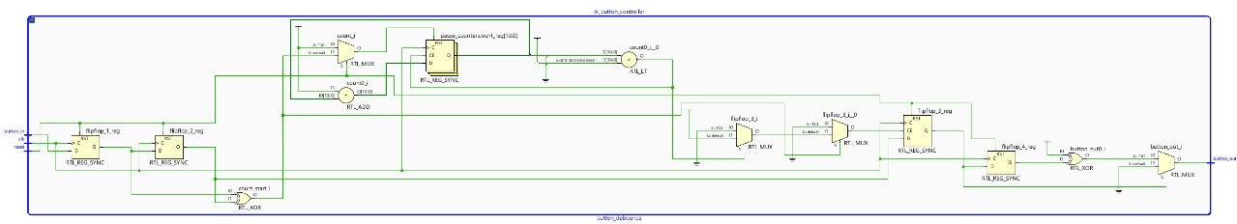
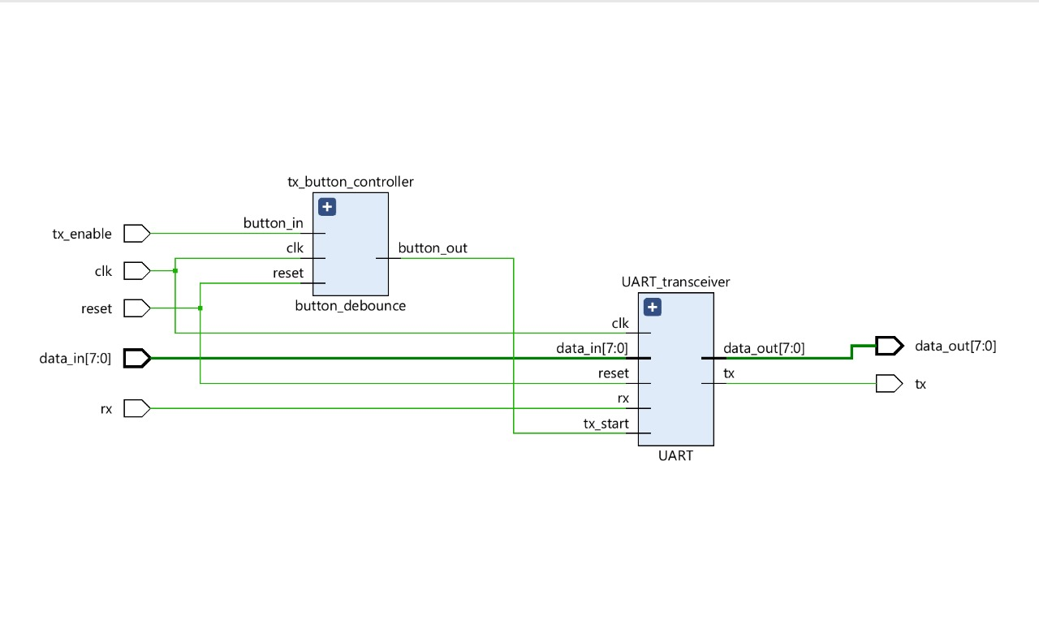
- RTL:
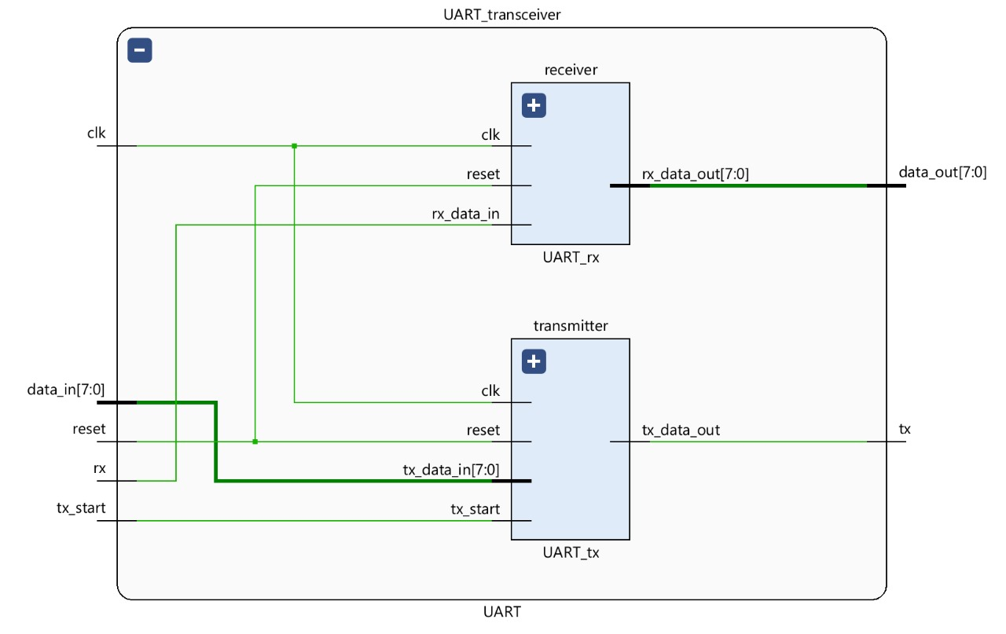

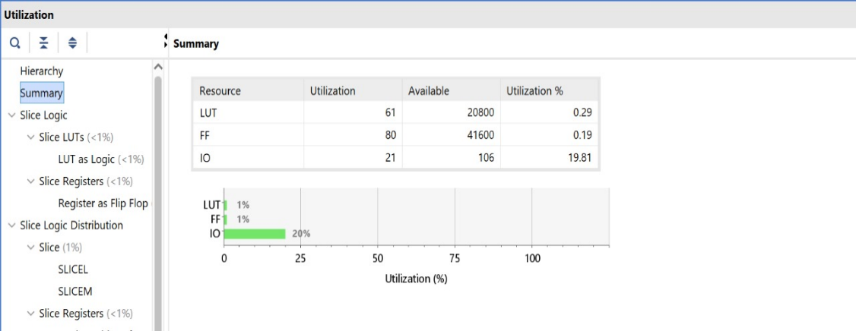
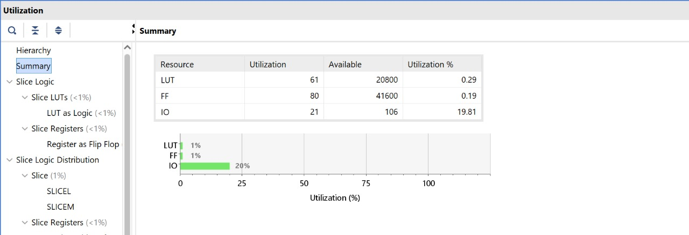
- Resource Utilization summary table:

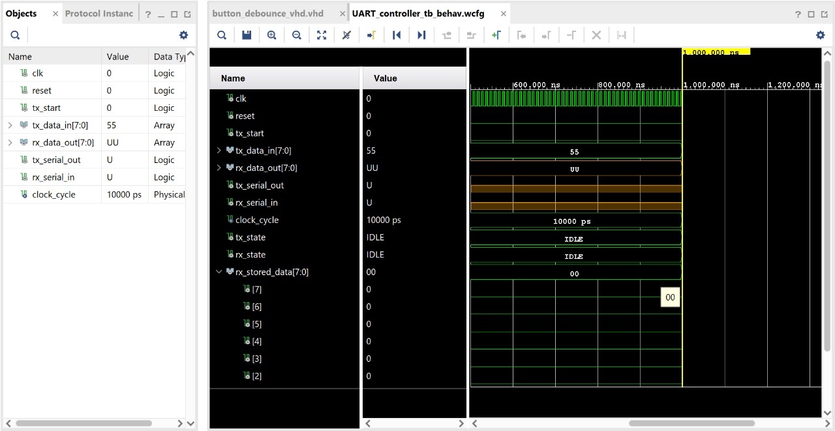
- Output Waveform:

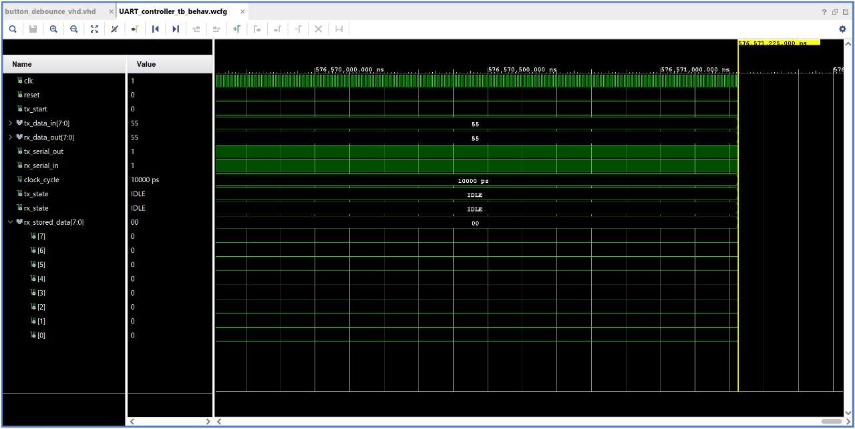
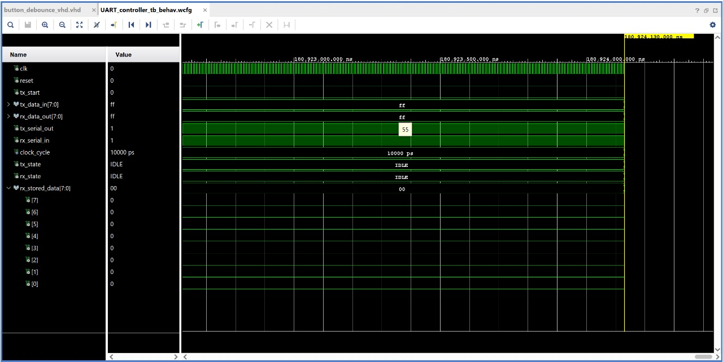
- Hardware Images:

- Transmitting ‘h’ from Tera term and receiving ASCII of ‘h’-‘01101000’ on Basys3 board
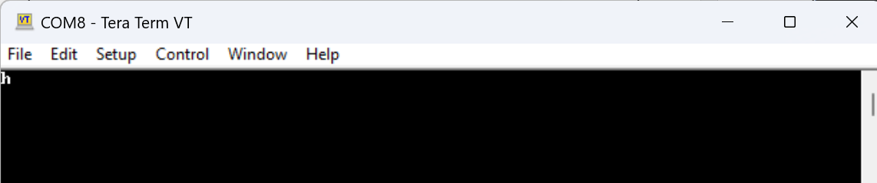
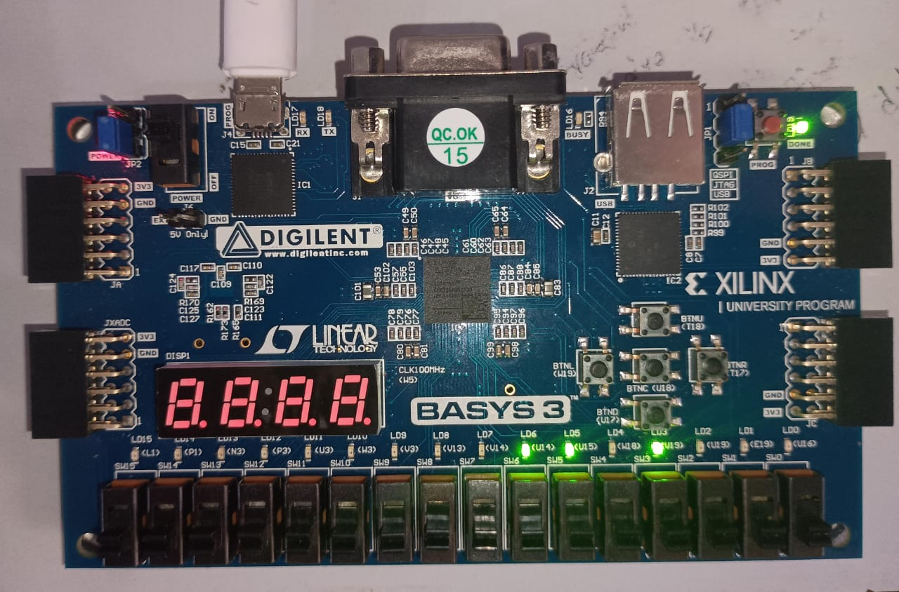
- Transmitting ‘e’ from Tera term and receiving ASCII of ‘e’-‘01100101’ on Basys3 board
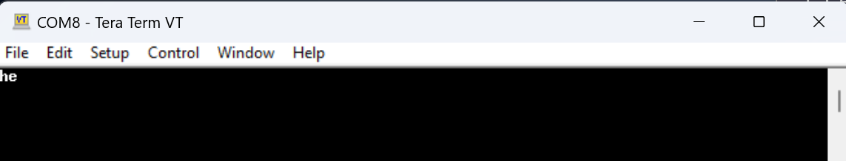
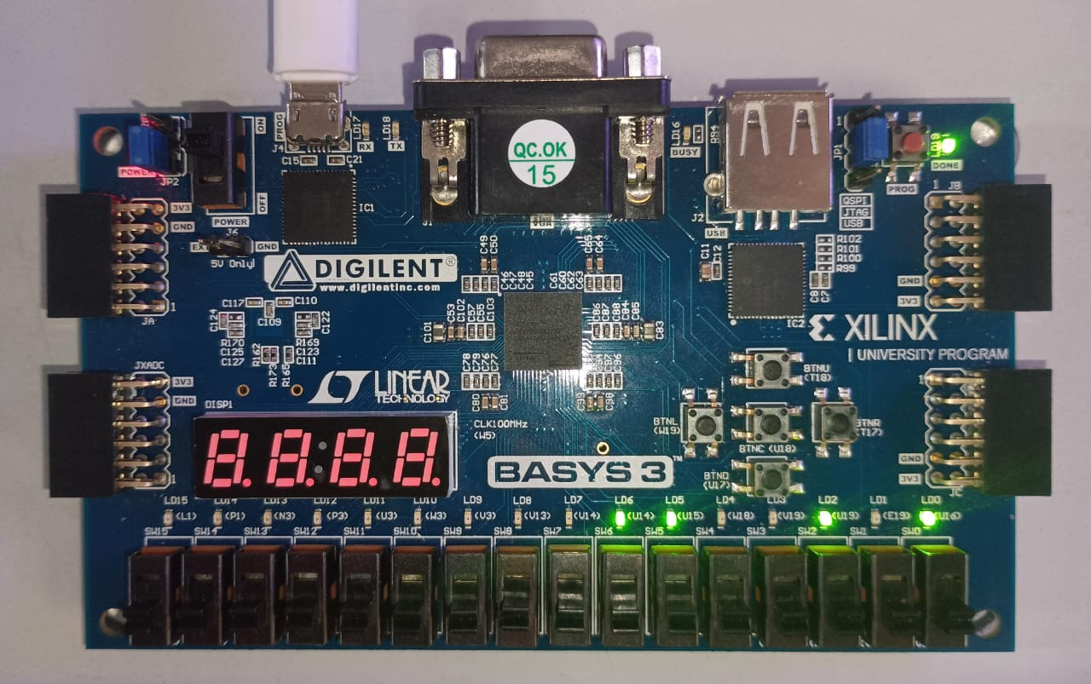
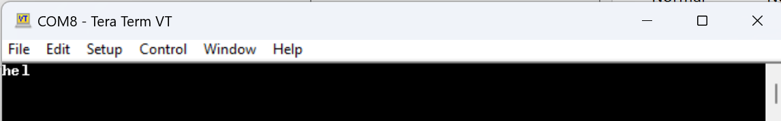
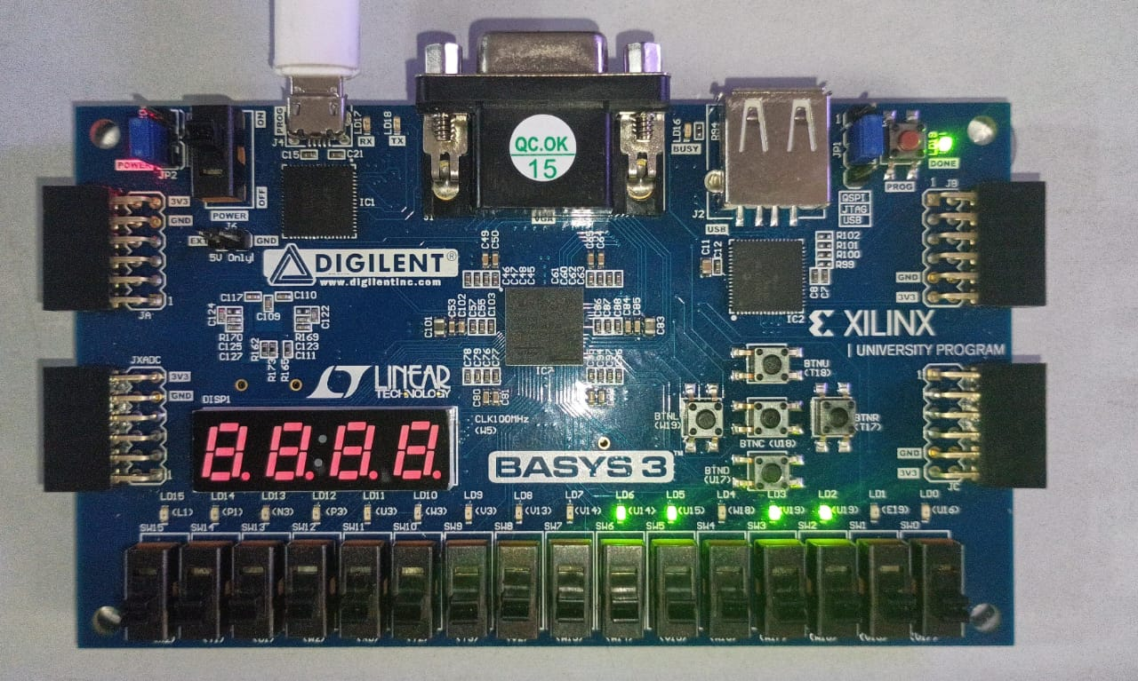
- Transmitting ‘l’ from Tera term and receiving ASCII of ‘l’-‘01101100’ on Basys3 board

- Transmitting ASCII of ‘l’-‘01101100’ from Basys3 board and pressing BTNC(U18) receives ‘l’ in Tera Term
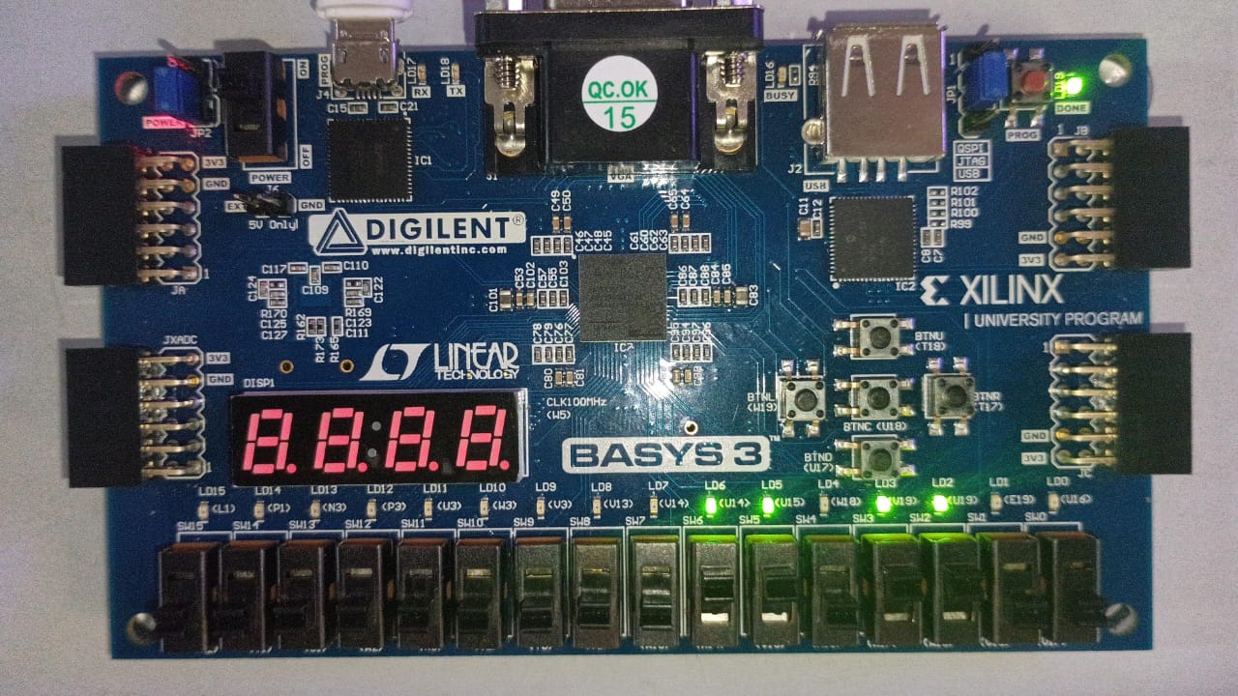
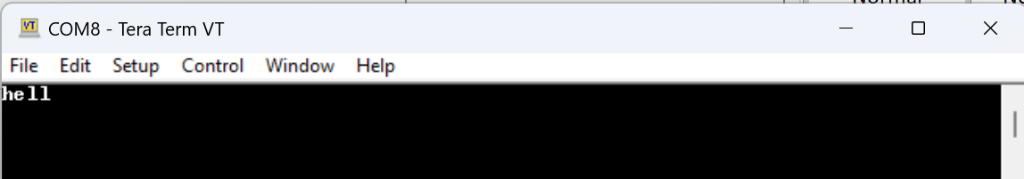
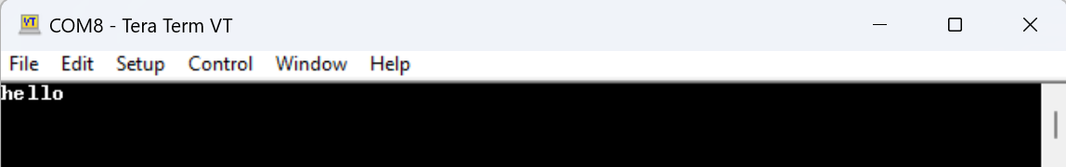
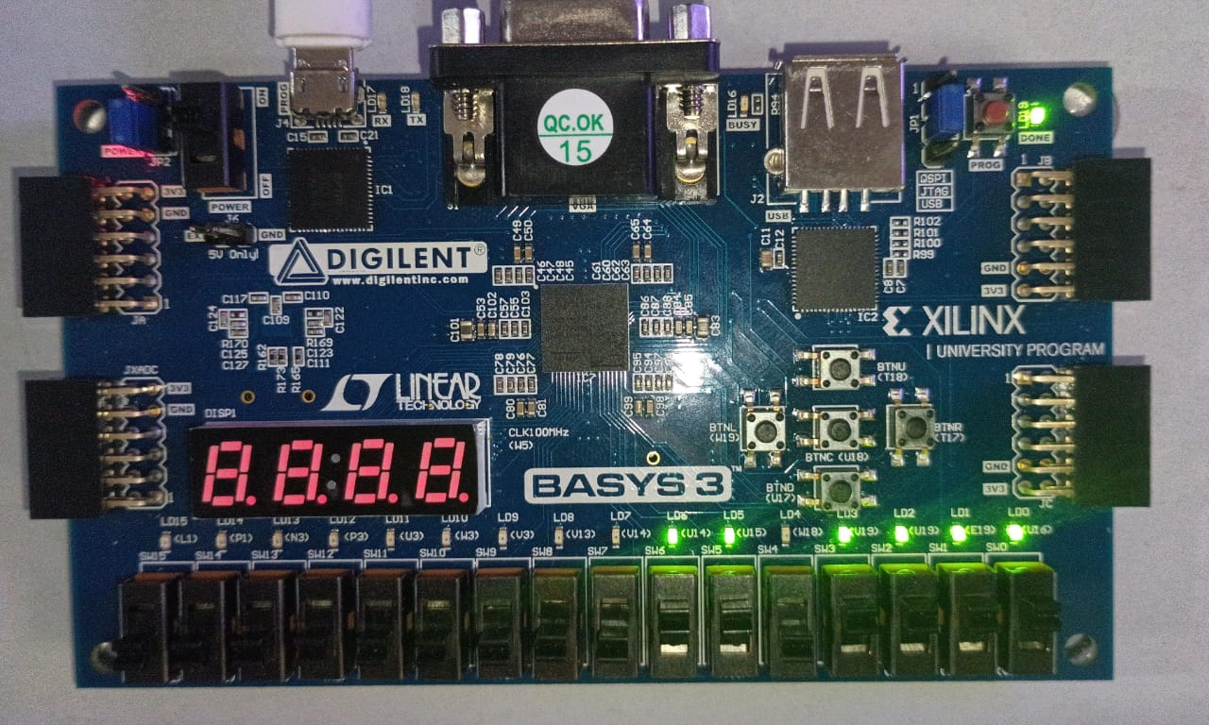
- Transmitting ASCII of ‘o’-‘01101111’ from Basys3 board and receiving ‘o’ in Tera Term

